WORKSHEET 6.1
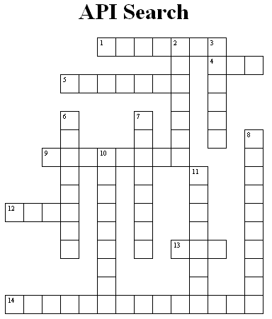

ACROSS
1 Class that constructs a newly allocated Integer object that represents the specified int value.
4 Method in the Math class that finds the absolute value of the passed in value
5 Returns a pseudorandom, uniformly distributed int value between 0 (inclusive) and the specified value (exclusive), drawn from this random number generator's sequence.
9 Method in the Point2D class that returns the distance from this Point2D object to a specified Point2D object.
12 Method in the Math class that finds the square root of the passed in value
13 Method in the Math class that returns the answer of the first parameter raised to the power of the second parameter
14 Method in the Line2D class that tests if the line segment from (X1, Y1) to (X2, Y2) intersects this line segment.

DOWN
2 Method in the Color class that returns the blue component in the range 0-255 in the default RGB space.
3 Class that allows us to generate pseudorandom numbers.
6 Method in the Color class that creates a new Color that is a brighter version of this Color.
7 Method in the String class that returns true if and only if this string contains the specified sequence of char values.
8 Method in the DrawingTool class that allows us to fill in a circle
10 Method in the Math class that converts an angle measured in radians to an approximately equivalent angle measured in degrees.
11 Method in DrawingTool class that allows us to draw an oval

